AES-X098C
SC-03-06

DRAFT
AES standard for metadata –
Processing and handling history
of audio objects

Abstract
This standard provides a vocabulary to be used in describing structural and administrative metadata about the processing and handling history of audio objects during audio preservation activities. Some implementations also refer to this metadata as technical metadata. The characteristics of the processing and handling of audio objects captured by this standard may be of use to audio communities beyond the audio preservation community.

An AES standard implies a consensus of those directly and materially affected by its scope and provisions and is intended as a guide to aid the manufacturer, the consumer, and the general public. The existence of an AES standard does not in any respect preclude anyone, whether or not he or she has approved the document, from manufacturing, marketing, purchasing, or using products, processes, or procedures not in agreement with the standard. Prior to approval, all parties were provided opportunities to comment or object to any provision. Attention is drawn to the possibility that some of the elements of this AES standard or information document may be the subject of patent rights. AES shall not be held responsible for identifying any or all such patents. Approval does not assume any liability to any patent owner, nor does it assume any obligation whatever to parties adopting the standards document. This document is subject to periodic review and users are cautioned to obtain the latest edition. Recipients of this document are invited to submit, with their comments, notification of any relevant patent rights of which they are aware and to provide supporting documentation.
Contents

Introduction 4
0 Preamble 4
0.1.1 Decimal points 4
0.1.2 Data representation 4
0.1.3 Case sensitivity 4
0.1.4 Logical conventions and data types 4
1 Scope 5
2 Normative references 5
3 Definitions and abbreviations 5
3.1 Audio object 5
3.2 Instance Document 6
3.3 Signal graph 6
3.3.1 Patching 8
4 Process history document structure 10
4.1 Instance document scope 10
4.2 Document root 10
4.3 processHistoryType 10
4.3.8 processEvent 11
4.3.9 processEventType 11
4.3.9.6 media 12
4.3.9.7 mediaType 13
Annex A (Normative) Process History XML Schema 25
NOTE This filename will be confirmed on publication on this standard, and may be updated in future versions of this standard. 26
Annex B: (Informative) Schema Listing 27

Foreword
This foreword is not part of the AESxx-xxxx AES standard for metadata – Processing and handling history of audio objects.

Work on this project began in earnest in 2002 following a series of meetings that the chair attended at the Library of Congress in which the subject of technical metadata requirements for audio were discussed. Since that time, Harvard University developed a working proof of concept of the metadata schema herein described, which was shared with Indiana University as a part of the National Endowment for the Humanities funded Sound Directions research project. During that project, IU developed its own prototype tools that implemented that earlier draft of the schema. This version retains all of the earlier functional requirements of the earlier draft while offering a somewhat simplified implementation.

The members of the writing group that developed this document in draft are:

David Ackerman
Chair, working group SC-03-06

Note on normative language
In AES standards documents, sentences containing the word “shall” are requirements for compliance with the document. Sentences containing the verb “should” are strong suggestions (recommendations). Sentences giving permission use the verb “may”. Sentences expressing a possibility use the verb “can”.

DRAFT
AES standard for metadata –
Processing and handling history
of audio objects

Introduction
This standard sets out the vocabulary to be used in describing the processing and handling history of audio objects in audio preservation work. This metadata, sometimes referred to as ‘process history’, 'digital provenance' (or ‘digi-prov’), describes the details of how audio objects are treated and/or migrated. Essentially it provides the ‘who’, ‘where’, ‘what’, 'when' and ‘how’ information that clarifies the provenance of the audio object with regard to the work that has been done to restore and/or preserve the object. This vocabulary is expressed in the form of an Extensible Markup Language (XML) schema. By doing so it provides a structured human readable instance document that can be easily parsed and manipulated using any of a number of freely available programming libraries and tools.

0 Preamble

0.1.1 Decimal points
According to IEC directives, the comma is used in all text to indicate the decimal point. However, in the specified coding, including the examples shown, the full stop is used as in IEC programming language standards.

0.1.2 Data representation
In this standard, all coding and data representations are printed in an equally-spaced font. Inherited elements and attributes are printed in an italicized equally-spaced font.

0.1.3 Case sensitivity
All element, attribute, data type and constant names shall be case sensitive.

0.1.4 Logical conventions and data types
In this standard, all elements, attributes and custom data types are defined in the lower-camel-case coding convention. For example, lowerCamelCase.

This standard is implemented as an Extensible markup language (XML) schema according to the W3C XML schema recommendation. The full listing in the schema format is provided in this documents appendices.

This standard relies on a number of data types that are defined by the W3C. See Clause 2 Normative references. W3C defined datatypes appear in the text prefixed with the ‘xsd:’ namespace qualifier. The following W3C data types are used:

xsd:dateTime
xsd:ID
xsd:IDREF
xsd:IDREFS
xsd:positiveInteger
xsd:string

This standard also relies on data types defined in AES57-2011 AES standard for audio metadata – Audio object structures for preservation and restoration. AES57 datatypes appear in the text prefixed with the ‘aes57:’ namespace qualifier. The following AES57 datatypes are used:

aes57:audioObjectType
aes57:timeRangeType

This standard also relies on data types defined in AES60-2011 AES standard for audio metadata – AES standard for audio metadata – Core audio metadata. AES60 datatypes appear in the text prefixed with the ‘aes60:’ namespace qualifier. The following AES60 datatypes are used:

aes60:editUnitNumberType
aes60:contactDetailsType

Finally, this standard defines a number of custom data types according to the rules of the W3C XML schema recommendation. These types are defined throughout the text as they are encountered in the element and attribute definition listings.

1 Scope
This standard concerns the technical documentation of the processing and handling of audio files and physical audio formats carried out during audio preservation and restoration work. This documentation, here referred to as metadata, provides a description of where the work occurred, who did the work, when the work was completed, and how the work was done, including a full description of the audio signal chain as it was configured during the processing.

2 Normative references
The following standards contain provisions which, through reference in this text, constitute provisions of this document. At the time of publication, the editions indicated were valid. All standards are subject to revision, and parties to agreements based on this document are encouraged to investigate the possibility of applying the most recent editions of the indicated standards.

AES57-2011, AES standard for audio metadata – Audio object structures for preservation and restoration; Audio Engineering Society, New York, NY., US.

AES60-2011, AES standard for audio metadata – Core audio metadata; Audio Engineering Society, New York, NY., US.

W3C XML Schema Part 1: Structures Second Edition, W3C Recommendation 28 October 2004.

W3C XML Schema Part 2: Datatypes Second Edition, W3C Recommendation 28 October 2004.

W3C XML Linking Language (XLink) Version 1.1: W3C Working Draft 07 July 2005.

I think we need at least an Informative Reference to the BWF (aka AES 31-2) here, partly because we are talking about the “handling of audio files” and partly because Figure 1 makes direct reference to it. Further, we ought to cite EBU Tech 3285 Supplement 5 (http://tech.ebu.ch/publications/tech3285S5), for that is a most useful way to embed the XML in the audio file itself, particularly when sending a file somewhere.

3 Definitions and abbreviations

3.1 Audio object
A general term used to describe physical audio carriers, and digital audio in the form of files and streams.

For the purposes of this document, the term physical audio carriers shall be understood to mean only those carriers to which an audio data essence is intrinsically bound to the physical object. For example, an audio DAT tape is a physical digital audio object. Wave files on the other hand are file based digital audio objects. They can be moved, copied, and renamed without the need to play the audio essence. In the latter case, the file exists on a storage device, but it is not intrinsically bound to that device. Therefore there is no need to describe the physical storage given its transient nature.

For additional details see AES57-2011, AES standard for audio metadata – Audio object structures for preservation and restoration.

3.2 Instance Document
A document that conforms to the minimally required set of elements and attributes defined by an XML schema.

3.3 Signal graph
An input through output tracing of all audio signal routing through a series of devices and or software describing the total processing applied to the audio signal during a process event.
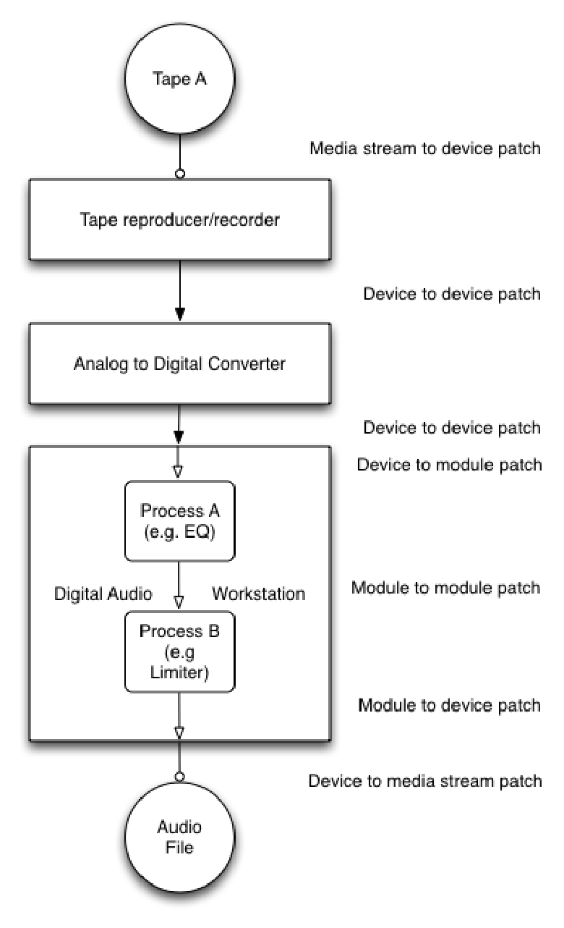
Figure 1. Example of a Signal graph

3.3.1 Patching
Signal flow is expressed by forming relationships between channels of three types of elements. They are device elements, module elements and media elements. A device element represents a single audio device in the signal graph. It may contain 1..n module elements, which each represent a sub-processor of the device. Media elements contain an audioObject element which has stream elements that represent audio channels from a media source to a media destination. Patching is the process of forming ID-IDREF relationships between streams and channels of devices, between multiple devices, between devices and their modules, and between multiple modules within a device to describe the audio signal flow.

3.3.1.1 Device and module patching
Device channels and module channels are divided into inputChannels and outputChannels for each type of element. Each of these channel elements in turn has an attribute that indicates an incoming signal and one that indicates an outgoing signal. This allows the signal graph to express both relationships between external devices as well as an internal signal path for each device through the use of module elements. In this scheme, a device’s input channels can be routed to the inputs of different modules or to the device output channels.

In all cases, these elements shall use ID-IDREF relationships to express the signal routing.

When forming relationships between devices or within a device and its modules the following rules shall apply:
- Rule 1 | - A device outputChannel may be patched to one or more device inputChannels. In this configuration the outputChannel’s outgoingSignal attribute shall reference the ID attributes of all of the device inputChannels that it sends signal to. A reciprocal link shall be formed by setting the destination device inputChannel’s incomingSignal attribute to reference the ID of the device outputChannel.
- Rule 2 | - A device inputChannel may be patched to one or more module inputChannels. In this configuration the device inputChannel’s outgoingSignal attribute shall reference the ID attributes of all of the module inputChannels that it sends signal to. A reciprocal link shall be formed by setting the module inputChannel’s incomingSignal attribute to reference the ID of the device inputChannel.
- Rule 3 | - A module outputChannel may be patched to one or more module inputChannels provided that all modules reside in the same device. In this configuration the module outputChannel’s outgoingSignal attribute shall reference the ID attributes of all of the module inputChannels that it sends signal to. A reciprocal link shall be formed by setting the module inputChannel’s incomingSignal attribute to reference the ID of the module outputChannel.
- Rule 4 | - A module outputChannel may be patched to one or more device outputChannels In this configuration the module outputChannel’s outgoingSignal attribute shall reference the ID attributes of all of the device outputChannels that it sends signal to. A reciprocal link shall be formed by setting the device outputChannel’s incomingSignal attribute to reference the ID of the module outputChannel.
- Rule 5 | - A device inputChannel may be patched to one or more of the same devices outputChannel. In this configuration the device inputChannel’s outgoingSignal attribute shall reference the ID attributes of all of the device outputChannels that it sends signal to. A reciprocal link shall be formed by setting the device outputChannel’s incomingSignal attribute to reference the ID of the device inputChannel.
            - These rules make it possible to represent a straight one-to-one connection or to represent a signal multiplier, but not a signal mixer.

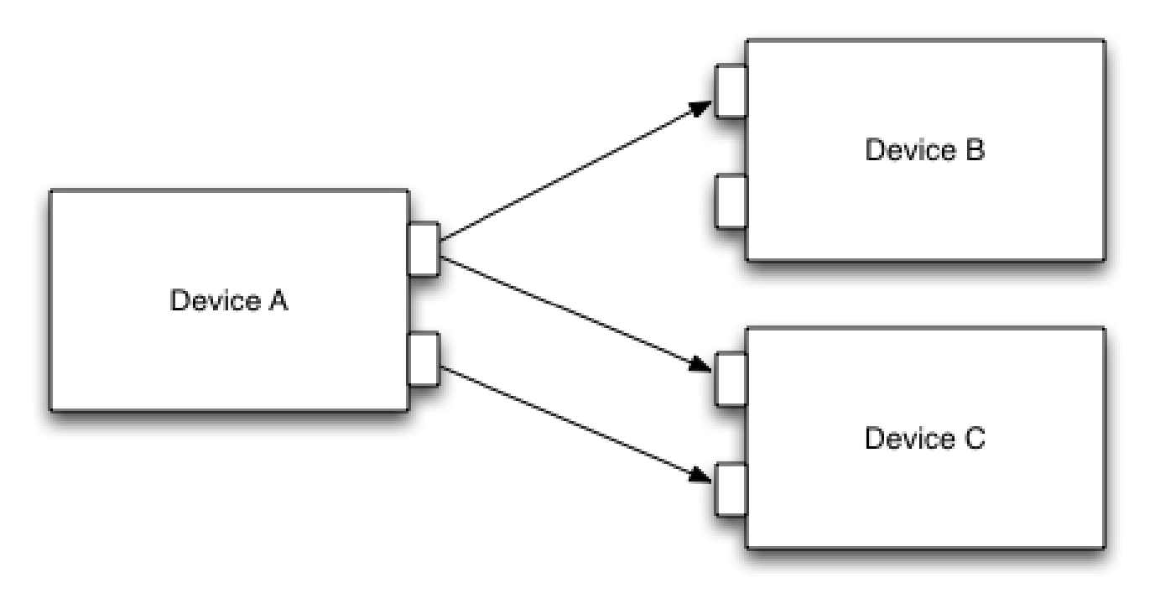

Figure 2. Example of rule 1.

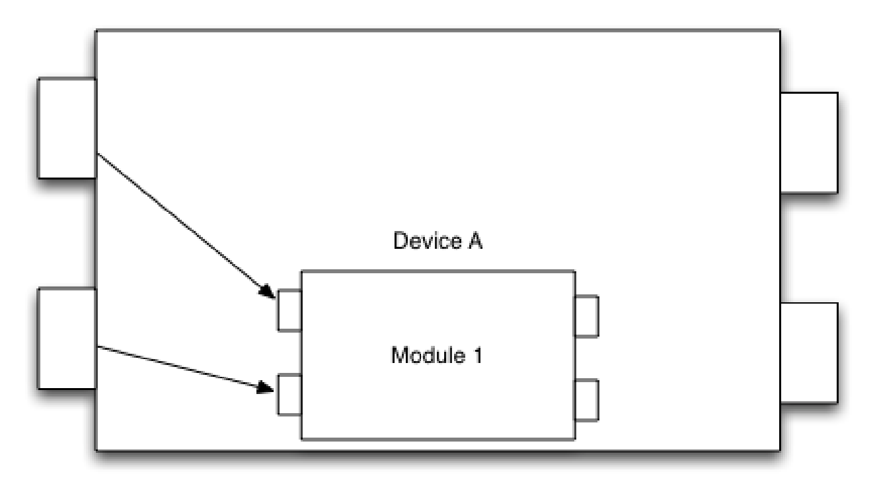

Figure 3. Example of rule 2.

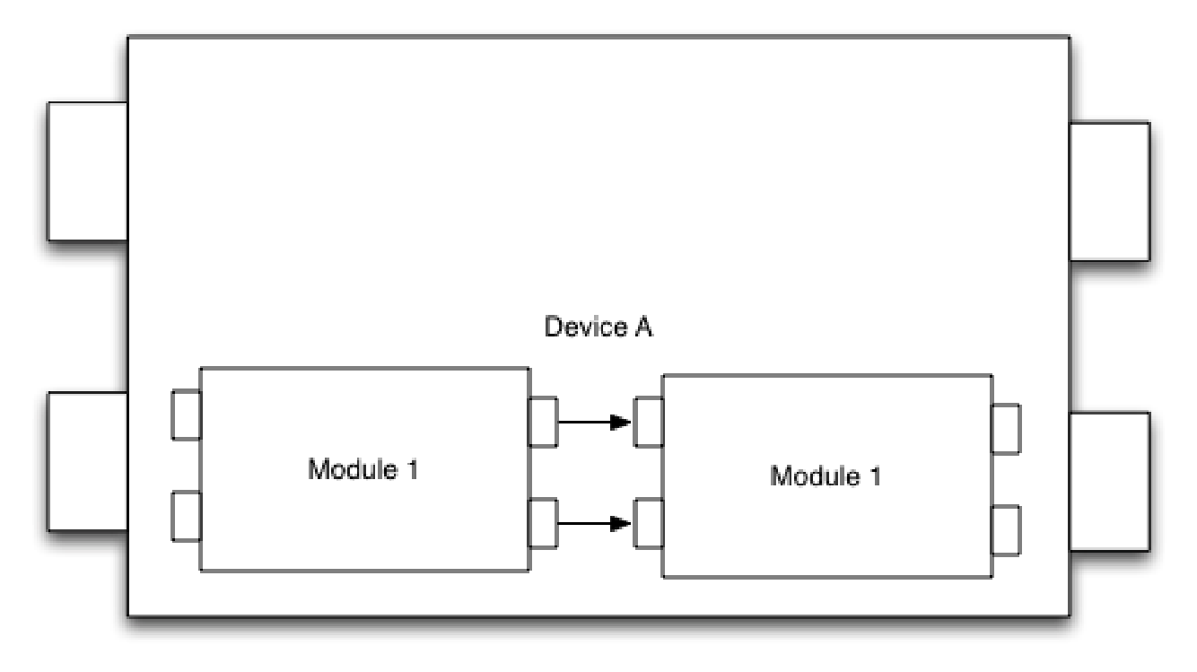
Figure 4. Example of rule 3.

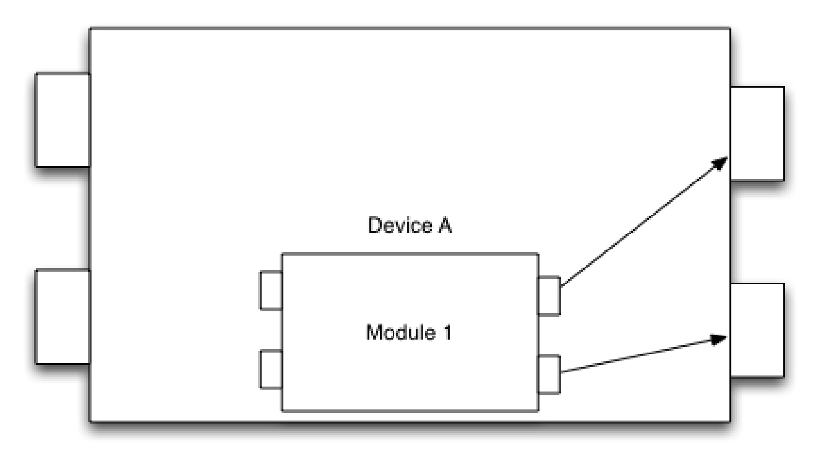

Figure 5. Example of rule 4.

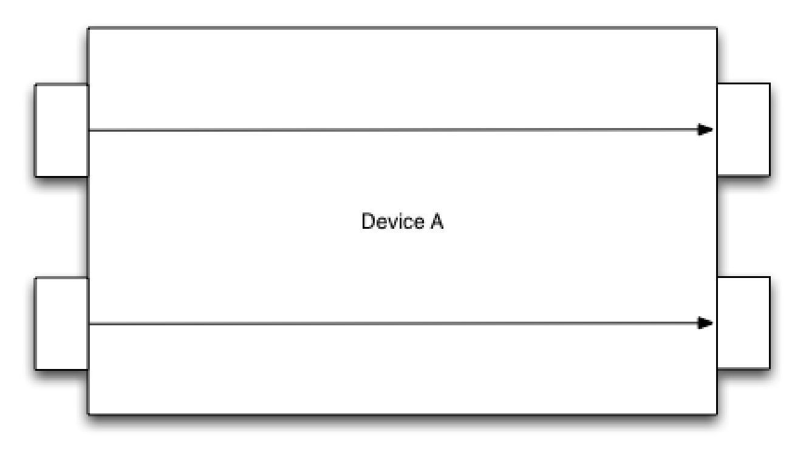

Figure 6. Example of rule 5.

3.3.1.2 Media patching
In addition to input and output channels, devices also may have media channels. Media channels represent the ability of the device to play an audio signal from or record an audio signal to media that the device is equipped to play or record.

This standard defines media elements to represent the real world media object. Each media element contains an audioObject element which in turn contains one or more region elements. The regionRef attribute of the media element sets the scope of the media element to a particular region of the child audioObject element. This region element contains one or more stream elements, each with a unique ID attribute. The value of this ID attribute shall be used as the value of the incomingStream attribute on inputMediaChannels when the media was played during the process event. The value of this ID attribute shall be used as the value of the outgoingStream attribute on outputMediaChannels when the media was recorded during the process event.

When forming relationships between a device’s media channels and an audio stream the following rules shall apply.

- Rule 6 | - When representing the playback of a media object, the value of the ID of the audioObject’s stream element shall be used as the value of the playbackMediaChannel elements incomingStream attribute. The outgoingSignal attribute of the playbackMediaChannel element may be patched to one or more of the device’s module inputChannel elements or to one or more of the same devices outputChannel elements. Accordingly, the value of the ID attribute of the patched module inputChannel or of the device outputChannel shall be used as the value of the outgoingSignal attribute.
- Rule 7 | - When representing the recording of a media object, the value of the incomingSignal attribute of the recordMediaChannel shall be set to the value of the ID of either the last module outputChannel in the device signal graph or to the ID of a device inputChannel if the device contains no modules. The value of the recordMediaChannel elements outgoingStream attribute shall be set to the value of the ID attribute of the audioObject stream element that represents the recorded audio.

EXAMPLE

This example shows two XML fragments. The first is an excerpt from an aes57:audioObject element. Notice the ID attribute of the stream.

<audioObject …
<face …
<region …
<stream ID="_58452545-9ADE-4B87-9105-7581B65FCEB0" faceRegionRef="_F2DEA464-88F5-47CA-9039-A9BD94B35AD5" label="Stream 1" xsi:type="streamType">
…
</stream>
</region>
</face>
…
</audioObject>

Next is a fragment of a device element containing a module element. Notice the xml ID of the playbackMediaChannel.

<device…
<playbackMediaChannel ID="ID085" incomingStream="_58452545-9ADE-4B87-9105-7581B65FCEB0"
outgoingSignals="ID093" label="1"/>
…
<module …>
<inputChannel ID="ID093" incomingSignal="ID085" outgoingSignals="ID072" label="label83" routing="INPUT"/>
</device>

Notice that the stream ID from the audioObject and the incoming stream IDREF from the playbackMediaChannel match, that the ID from the playbackMediaChannel and the module incomingSignal IDREF match and the playbackMediaChannel’s outgoingSignals IDREFs and the ID of the module match.

4 Process history document structure

4.1 Instance document scope
An instance document’s scope shall be limited to the description of the handling and preservation activities for a single source audioObject and the resulting derivations of that source audioObject.

4.2 Document root
The root of the instance document is the processHistory element. All other elements in the instance document shall be contained between the <processHistory> and </processHistory> tags.

4.3 processHistoryType
NAME | DATA TYPE | OCCURS |  | KIND | DEFAULT VALUE
 |  | MIN | MAX
ID | xsd:ID | 1 | 1 | ATTRIBUTE | NONE
schemaVersion | xsd:string | 1 | 1 | ATTRIBUTE | 1.0.0
reformattingGuidelineText | xsd:string | 0 | unbounded | ELEMENT | NONE
reformattingGuidelineRef | locStringType | 0 | unbounded | ELEMENT | NONE
workerList | workerListType | 1 | 1 | ELEMENT | NONE
processEvent | processEventType | 1 | unbounded | ELEMENT | NONE

4.3.1 ID
The ID attribute shall be used to provide an XML ID for the processHistory element. Care shall be taken to ensure that the ID attribute is a unique value within the instance document. Further, since the instance document may be included in other XML documents, problems can occur if two instance documents share the same values for ID attributes. Therefore ID attributes should be made unique both within and across instance documents.

4.3.2 schemaVersion
The schemaVersion shall contain a fixed version string for the process history schema defined in this standard.

4.3.3 reformattingGuidelineText
The reformattingGuidelineText element may be used to convey discursive descriptions of the preservation methodology and or any business rules used as a part of the audio preservation process.

4.3.4 reformattingGuidelineRef
The reformattingGuidelineRef element may be used to provide a link to an external document containing discursive descriptions of the preservation methodology and or any business rules used as a part of the audio preservation process. The reformattingGuidelineRef data type shall be locStringType.

4.3.5 locStringType
The locStringType data type shall be a wrapper for the W3C XLink simple link attribute group. Further information about XLink may be found at http://www.w3.org/TR/xlink/.

4.3.6 workerList
The workerList element shall contain a list of the people who have participated in the work described in the enclosing process history instance document. The workerList element data type shall be workerListType.

4.3.7 workerListType
NAME | DATA TYPE | OCCURS |  | KIND | DEFAULT VALUE
 |  | MIN | MAX
worker | workerType | 1 | unbounded | ELEMENT | NONE

4.3.7.1 worker
The worker element shall be used to describe a single person who carried out an action described in a process history instance document.

4.3.7.2 workerType extends AES60:contactDetailsType
NAME | DATA TYPE | OCCURS |  | KIND | DEFAULT VALUE
 |  | MIN | MAX
ID | xsd:ID | 1 | 1 | ATTRIBUTE | NONE
n/a | Aes60:contactDetailsType | 1 | 1 | BASE DATA TYPE | NONE

4.3.7.2.1 ID
The ID attribute shall be used to provide an XML ID for the worker element. Care shall be taken to ensure that the ID attribute is a unique value within the instance document. Further, since the instance document may be included in other xml documents, problems can occur if two instance documents share the same values for ID attributes. Therefore ID attributes should be made unique both within and across instance documents.

4.3.7.2.2 contactDetailsType
The workerType is an extension of AES60’s contactDetailsType. As such, it inherits all of the elements and attributes of that base data type. Using these data fields, the workerType shall be used to identify a single person who carried out an action described in a process history instance document. The contactDetailsType data type is described in AES60-2011, AES standard for audio metadata – Core audio metadata.

4.3.8 processEvent
The processEvent element shall be used to describe a single step of work involved in the restoration and/or preservation of an audio object.

NOTE Each processEvent is bounded by the constraint that it shall have one or more input media objects and one or more output media objects. The event is therefore the documentation that describes what was done to affect the input media to create the resulting output media. It is possible for the input and output media to refer to the same media element. For example, the action of cleaning a record, where both the input and output media of the event point to the same audioObject XML instance describing the record.

4.3.9 processEventType
NAME | DATA TYPE | OCCURS |  | KIND | DEFAULT VALUE
 |  | MIN | MAX
sequenceNumber | xsd:positiveInteger | 1 | 1 | ATTRIBUTE | NONE
description | xsd:string | 1 | 1 | ATTRIBUTE | NONE
creationDateTime | xsd:dateTime | 1 | 1 | ATTRIBUTE | NONE
workers | xsd:IDREFS | 1 | 1 | ATTRIBUTE | NONE
eventTimeline | aes57:timeRangeType | 0 | 1 | ELEMENT | NONE
media | mediaType | 1 | unbounded | ELEMENT | NONE
treatmentNote | xsd:string | 0 | unbounded | ELEMENT | NONE
deviceChain | deviceChainType | 0 | 1 | ELEMENT | NONE
qualityAssurance | qualityAssuranceType | 0 | unbounded | ELEMENT | NONE

4.3.9.1 sequenceNumber
The sequenceNum attribute shall be used to assign a positive integer to the enclosing processEvent element that is unique within the scope of the instance document. This number will indicate the order in which processEvent actions occurred, with the lowest number being the first action taken and the highest the last.

4.3.9.2 description
The description attribute shall be used to provide a brief overview of what action the enclosing process event describes.

4.3.9.3 creationDateTime
The creationDateTime attribute shall be used to indicate the time and date the processEvent occurred. The XML schema dateTime data type shall be used to encode the time and date.

4.3.9.4 workers
The workers attribute shall contain an XML IDREFS list of IDREF pointers that reference the ID of each of the workers from the workerList element (see 4.3.6) who participated in the work described by the processEvent element.

4.3.9.5 eventTimeline
The eventTimeline element shall be used whenever the processEvent contains work that involves media playback, media recording, or other media processing that involves reading or writing audio data in relation to an audio clock source. When present the eventTimeline shall provide a time-line comprising a start time address and a duration measured from that starting point. This time-line is an abstract representation of presentation time which extends from the start time uninterrupted through to the end of the time-line as determined by the given duration.

NOTE Start time + duration equals the end point of the time-line.

All media elements and other time-based processing information (e.g. device parameters) shall be referenced to the eventTimeline element. The edit unit rate of the eventTimeline shall be set to the same edit unit rate of the media used in the processEvent. If the processEvent contains media of differing edit

unit rates, the media with the highest resolution edit unit rate shall determine the edit unit rate of the processEvent.

The eventTimeline element data type shall be aes57:timeRangeType as described in AES57-2011, AES standard for audio metadata – Audio object structures for preservation and restoration.

4.3.9.6 media
The media element shall be used to describe a single audio source that is used in the processEvent. The media element’s data type shall be mediaType.

4.3.9.7 mediaType
NAME | DATA TYPE | OCCURS |  | KIND | DEFAULT VALUE
 |  | MIN | MAX
regionRef | xsd:IDREF | 1 | 1 | ATTRIBUTE | NONE
status | statusType | 1 | 1 | ATTRIBUTE | NONE
audioObject | aes57:audioObjectType | 1 | 1 | ELEMENT | NONE
sourceInTime | aes60:editUnitNumberType | 0 | 1 | ELEMENT | NONE
eventTimelineInTime | aes60:editUnitNumberType | 0 | 1 | ELEMENT | NONE
eventTimelineDuration | aes60:editUnitNumberType | 0 | 1 | ELEMENT | NONE

4.3.9.7.1 regionRef
The regionRef attribute shall be used to indicate which region element in the audioObject (see 4.3.9.7.4) is referenced in this media element. Only one region element shall be referenced in a media element.

4.3.9.7.2 status

The status attribute shall be used to indicate whether the media source described by the audioObject element (see 4.3.9.7.4) has been archived or deleted as a part of the workflow. The status attribute’s data type shall be statusType.

4.3.9.7.3 statusType
The statusType is a restricted list of string values. The possible values shall be:
ARCHIVED
DELETED

4.3.9.7.4 audioObject
The audioObject element shall be used to include audioObject metadata as defined in AES57-2011, AES standard for audio metadata – Audio object structures for preservation and restoration. This metadata represents the media used during the processEvent.

When patching audioObject media to a device's playback or record media channels, the patch shall contain the XML ID attribute of one of the audioObject's stream elements. When presenting the stream to the user, applications should provide the context of both the stream's enclosing face and region labels.

4.3.9.7.6 sourceInTime
The sourceInTime element shall be used when an eventTimeline is present in the processEvent. The sourceInTime element’s data type shall be aes60:editUnitNumberType as described in AES60-2011, AES standard for audio metadata – Core audio metadata.

When present the sourceInTime element shall indicate the initial point in time that sound data is accessed in the media, as measured in the audioObject’s region elements internal timeline. When the eventTimeline and region element’s edit unit rates differ, the region element’s time shall be converted to the eventTimeline’s edit unit rate to resolve the conflict.

4.3.9.7.7 eventTimelineInTime
The eventTimelineInTime element indicates the point on the eventTimeline where the audio addressed by the sourceInTime element is placed on the eventTimeline. It’s data type shall be aes60:editUnitNumberType as described in AES60-2011, AES standard for audio metadata – Core audio metadata.

4.3.9.7.6.8 eventTimelineDuration
The eventTimelineDuration element indicates the duration of the audio clip that shall be placed on the eventTimeline. It’s data type shall be aes60:editUnitNumberType as described in AES60-2011, AES standard for audio metadata – Core audio metadata.

4.3.9.8 treatmentNote
The treatmentNote element may be used to provide a free-text description of an action that was undertaken as a part of the processEvent which cannot be adequately described through the deviceChain and its sub-elements and attributes.

4.3.9.9 deviceChain
The deviceChain element shall contain a list of device elements that together form the signal graph including all playback and recording apparatus, and all signal processing devices applied to the audio signal.

4.3.9.10 deviceChainType

4.3.9.10.1 label
The label attribute may be used to give a descriptive name to the signal graph represented by the deviceChain.

4.3.9.10.2 masterSyncDeviceRef
The masterSyncDeviceRef shall contain the ID attribute of the device in the deviceChain that acts as the master sync clock. In cases where there is no such device, this masterSyncDeviceRef attribute shall be omitted.

4.3.9.10.3 device
The device element shall be used to describe the setup and characteristics of a single device in the signal graph.

4.3.9.10.4 deviceType

4.3.9.10.4.1 ID
The ID attribute shall be used to provide an XML ID for the device element. Care shall be taken to ensure that the ID attribute is a unique value within the instance document. Further, since the instance document may be included in other xml documents, problems can occur if two instance documents share the same values for ID attributes. Therefore ID attributes should be made unique both within and across instance documents.

4.3.9.10.4.2 functionalRole
The functionalRole attribute shall be used to indicate the functional role of the device.

4.3.9.10.4.3 functionalRoleType
The functionalRoleType shall be a restricted list of string values. The controlled vocabulary provided is intended to provide a general classification for most audio equipment. The most specific value that applies to the device should be chosen.

The possible values shall be:

ANALOG_TO_DIGITAL_CONVERTER
CLEANER
CONVECTION_OVEN
DECODER
DELAY_EFFECT
DE-ESSER
DENOISER
DIGITAL_TO_ANALOG_CONVERTER
DISTRIBUTION_AMPLIFIER
DYNAMIC_COMPRESSOR
DYNAMIC_EQUALISER
DYNAMIC_EXPANDER
DYNAMIC_LIMITER
ENCODER
EQUALISER/FILTER
LINE_BALANCE_INTERFACE/TRANSFORMER
MIXER
MS_MATRIX
NOISE_REDUCTION_ENCODER
NOISE_REDUCTION_DECODER
PREAMPLIFIER
RECORDER
REPRODUCER
REPRODUCER/RECORDER
SIGNAL_ANALYZER
SIGNAL_GENERATOR
SIGNAL_PROCESSOR
SPATIAL_EFFECT

4.3.9.10.4.4 userLabel
The userLabel attribute may be used to record a user-defined label or name for the device.

4.3.9.10.4.5 manufacturer
The manufacturer attribute shall be used to convey the name of the manufacturer of the device.

4.3.9.10.4.6 modelName
The modelName attribute shall be used to indicate the manufacturer-assigned model designation for the device.

4.3.9.10.4.7 serialNumber
The serialNumber attribute may be used to record the manufacturer-assigned serial number on the device.

4.3.9.10.4.8 syncSourceRefs
The syncSourceRefs attribute shall contain the ID attributes of the device input channels that receive sync when the device is slaved to an incoming external clock. In cases where external sync is not applicable, the syncSourceRef attribute shall be omitted

4.3.9.10.4.9 profile
The profile element may be used to reference external documents that contain performance specifications or proof of performance test results. The format of the external documents is beyond the scope of this standard. The profile element’s data type shall be locStringType (see 4.3.5).

4.3.9.10.4.10 inputChannel
The inputChannel element shall be used to represent a single input connection on the device. One inputChannel element shall be present for each audio stream passing through a physical input connection that is used on the device.

4.3.9.10.4.11 deviceInputChannelType

            - 4.3.9.10.4.11.1 ID
The ID attribute shall be used to provide an XML ID for the inputChannel element. This attribute is used to form signal graph patches (see 3.3.1). Care shall be taken to ensure that the ID attribute is a unique value within the instance document. Further, since the instance document may be included in other xml documents, problems can occur if two instance documents share the same values for ID attributes. Therefore ID attributes should be made unique both within and across instance documents.
            - 4.3.9.10.4.11.2 incomingSignal
The incomingSignal attribute shall contain the ID attribute of the device outputChannel that immediately precedes this inputChannel in the signal graph (see 3.3.1.1). If there is no preceding outputChannel in the signal path then this attribute shall be omitted.
            - 4.3.9.10.4.11.3 outgoingSignals
The outgoingSignals attribute shall contain the ID attributes of all patched module input channel and device output channel elements according to the rules outlined in 3.3.1.1.
            - 4.3.9.10.4.11.4 label
The label attribute shall be used to indicate the manufacturer-assigned name for the channel.

NOTE Often this label may be as simple as "Left" or "1".

            - 4.3.9.10.4.11.5 interface
The interface attribute shall be used to indicate the interface specification the channel utilizes.
            - 4.3.9.10.4.11.6 channelInterfaceType
The channelInterfaceType shall be a restricted list of string values. The possible values shall be:

ANALOG_BALANCED_TRS
ANALOG_BALANCED_XLR
ANALOG_RCA
ANALOG_UNBALANCED_TS
ATA
DIGITAL_AES_EBU
DIGITAL_SDIF
DIGITAL_SPDIF_COAXIAL
DIGITAL_SPDIF_OPTICAL
EIA_RS_232
EIA_RS_422
IEEE_1394
IEEE_1394b
LIGHT_PIPE
MIDI
RJ_45
SCSI
SONY_9_PIN
SUPER_CLOCK
USB_1_1
USB_2_0
USB_3_0
WORD_CLOCK

            - 4.3.9.10.4.11.7 routing
The routing attribute shall be used to indicate the signal-flow through the enclosing input channel. It’s data type shall be inputRoutingType.
            - 4.3.9.10.4.11.8 inputRoutingType
The inputRoutingType shall be a restricted list of string values. The possible values shall be:

INPUT
RETURN

4.3.9.10.4.12 outputChannel
The outputChannel element shall be used to represent a single output connection on the device. One outputChannel element shall be present for each audio stream passing through a physical output connection that is used on the device.

4.3.9.10.4.13 deviceOutputChannelType

            - 4.3.9.10.4.13.1 ID
The ID attribute shall be used to provide an XML ID for the outputChannel element. This attribute is used to form signal graph patches (see 3.3.1). Care shall be taken to ensure that the ID attribute is a unique value within the instance document. Further, since the instance document may be included in other xml documents, problems can occur if two instance documents share the same values for ID attributes. Therefore ID attributes should be made unique both within and across instance documents.
            - 4.3.9.10.4.13.2 incomingSignal
The incomingSignal attribute shall contain the ID attribute of the device inputChannel or the module outputChannel that immediately precedes this outputChannel in the signal graph (see 3.3.1.1) If nothing precedes the outputChannel in the signal path then this attribute shall be omitted.
            - 4.3.9.10.4.13.3 outgoingSignals
The outgoingSignals attribute shall contain the ID attributes of all patched device inputChannel elements according to the rules outlined in 3.3.1.1.
            - 4.3.9.10.4.13.4 label
The label attribute shall be used to indicate the manufacturer assigned name for the channel.

NOTE Often this label may be as simple as "Left" or "1".
            - 4.3.9.10.4.13.5 interface
The interface attribute shall be used to indicate the interface specification the channel utilizes. The interface attribute's data type shall be channelInterfaceType (see 4.3.9.10.4.11.6).
            - 4.3.9.10.4.13.6 routing
The routing attribute shall be used to indicate the signal-flow through the enclosing output channel. Its data type shall be outputRoutingType.
            - 4.3.9.10.4.13.7 outputRoutingType
The outputRoutingType shall be a restricted list of string values. The possible values shall be:

OUTPUT
THRU
SEND

4.3.9.10.4.14 playbackMediaChannel
The playbackMediaChannel element shall be used to indicate that a device is a reproducer capable of playing some type of audio object. Each playbackMediaChannel shall be scoped to interface with exactly one stream of the audio object. The playbackMediaChannel element’s data type shall be inputMediaChannelType.

4.3.9.10.4.15 inputMediaChannelType
            - 4.3.9.10.4.15.1 ID

The ID attribute shall be used to provide an XML ID for the playbackMediaChannel element. This attribute is used to form signal graph patches (see 3.3.1). Care shall be taken to ensure that the ID attribute is a unique value within the instance document. Further, since the instance document may be included in other xml documents, problems can occur if two instance documents share the same values for ID attributes. Therefore ID attributes should be made unique both within and across instance documents.
            - 4.3.9.10.4.15.2 incomingStream
The incomingStream attribute shall contain the ID attribute of the audioObject stream element that represents the audio track or channel that this playbackMediaChannel is playing. If the playbackMediaChannels is not playing an audio object then the incomingStream attribute shall be omitted.
            - 4.3.9.10.4.15.3 outgoingSignals
The outgoingSignals attribute shall contain the ID attributes of all patched module and device channel elements according to the rules outlined in 3.3.1.1.

            - 4.3.9.10.4.15.4 label
The label attribute shall be used to indicate the manufacturer-assigned name for the channel.

NOTE Often this label may be as simple as "Left" or "1".

4.3.9.10.4.16 recordMediaChannel
The recordMediaChannel element shall be used to indicate that a device is a recorder capable of recording some type of audio object. Each recordMediaChannel shall be scoped to interface with exactly one stream or track of the audio object. The recordMediaChannel element’s data type shall be ouputMediaChannelType.

4.3.9.10.4.17 outputMediaChannelType

            - 4.3.9.10.4.17.1 ID
The ID attribute shall be used to provide an XML ID for the recordMediaChannel element. This attribute is used to form signal graph patches (see 3.3.1). Care shall be taken to ensure that the ID attribute is a unique value within the instance document. Further, since the instance document may be included in other xml documents, problems can occur if two instance documents share the same values for ID attributes. Therefore ID attributes should be made unique both within and across instance documents.
            - 4.3.9.10.4.17.2 incomingSignal
The incomingSignal attribute shall contain the ID attribute of the device inputChannel or the module outputChannel that immediately precedes this outputChannel in the signal graph (see 3.3.1.1) If nothing precedes the outputChannel in the signal path then this attribute shall be omitted.
            - 4.3.9.10.4.17.3 outgoingStream
The outgoingStream attribute shall contain the ID attribute of the audioObject stream element that represents the audio track or channel to which this recordMediaChannel is recording. If the recordMediaChannel is not recording an audio object then the outgoingStream attribute shall be omitted.

            - 4.3.9.10.4.17.4 label
The label attribute shall be used to indicate the manufacturer-assigned name for the channel.

NOTE Often this label may be as simple as "Left" or "1".

4.3.9.10.4.18 settings
The settings element may be used to capture the state of the device setup with regard to its presets and parameters.

4.3.9.10.4.19 settingsType

            - 4.3.9.10.4.19.1 parameterGroup
The parameterGroup element shall aggregate together a series of parameter elements. It may be convenient to have multiple parameterGroup elements, each containing a set of parameter elements that relate to a specific sub-system of the device where the use of module elements would be inappropriate. In such cases, a single parameterGroup element should be reserved for a list of parameter elements which are of such a general nature as to preclude them from logically fitting into the other groups.

EXAMPLE –Audio Tape Reproducer

<parameterGroup groupName=”Channel assignment”>
<parameter name=”1” value=”Repro” …/>
<parameter name=”2” value=”Repro” …/>
</parameterGroup>
<parameterGroup groupName=”Track arming”>
<parameter name=”1” value=”Safe” …/>
<parameter name=”2” value=”Safe” …/>
</parameterGroup>
<parameterGroup>
<parameter name=”Tape Speed” value=”15” units=”INCHES PER SECOND” …/>
</parameterGroup>

            - 4.3.9.10.4.19.2 parameterGroupType

              - 4.3.9.10.4.19.2.1 groupName
The groupName attribute shall be used to indicate a descriptive name of a group of related parameter elements. When the enclosed parameter objects are of a general nature and not readily groupable by function or other sensible relation beyond the fact that they all exist in the device, the groupName attribute shall be omitted.
              - 4.3.9.10.4.19.2.2 programName
The programName attribute shall be used to indicate the stored name value for a device's program. In this context, a program is a set of instructions or an algorithm, usually hard-coded by the manufacturer. When a device has no concept of such programs, the attribute shall be omitted.
              - 4.3.9.10.4.19.2.3 presetName
The presetName attribute shall be used to indicate the stored name value for a device's preset. In this context, a preset is a named collection of parameters that can be recalled together to put a device into a desired state. When a device has no concept of presets, the attribute shall be omitted.
              - 4.3.9.10.4.19.2.4 softwareVersion
The softwareVersion attribute shall be used to indicate the version string for the software running on the device. When not applicable, the attribute shall be omitted.

              - 4.3.9.10.4.19.2.5 parameter
The parameter element shall be used to document the state of a single parameter on the device.

              - 4.3.9.10.4.19.2.6 parameterType

                - 4.3.9.10.4.19.2.6.1 name
The name attribute shall be used to indicate the manufacturer-assigned name of the parameter.

                - 4.3.9.10.4.19.2.6.2 units
The units attribute shall be used to indicate what scale of measure the value attribute is given in. For values that have no units, this attribute shall be omitted.

                - 4.3.9.10.4.19.2.6.3 parameterRepeatability
The parameterRepeatability attribute shall be used to indicate how accurately the enclosing parameter may be set repeatedly at the user interface of the device.

                - 4.3.9.10.4.19.2.6.4 interfaceRepeatabilityType
The interfaceRepeatabilityType is a restricted list of string values. The possible values shall be:

CLOSELY_REPEATABLE
NOT_REPEATABLE
FULLY_REPEATABLE

                - 4.3.9.10.4.19.2.6.5 automationPoint
The automationPoint element shall be used to define how the parameter relates to the eventTimeline (see 4.3.9.5). The value of the parameter shall be in effect from the point of the timestamp of the first automationPoint element until another automationPoint occurs. The handling of the change in value shall be determined by the automationPoint elements transition attribute.

                - 4.3.9.10.4.19.2.6.7 automationPointType

                - 4.3.9.10.4.19.2.6.7.1 value
                - The value attribute shall be used to indicate the value of the parameter as it appears in the user interface of the enclosing device. The value field shall only contain the value itself, whereas the scale or units shall be separately noted in the units attribute.

                - 4.3.9.10.4.19.2.6.7.2 transition
The transition attribute shall be used to indicate how a parameter value is changed from the previous value to the current value of the enclosing parameter element. The change may be either an INSTANTANEOUS change at the indicated timestamp location, or it may occur as a LINEAR_RAMP beginning at the timestamp of the previous automationPoint element and ending at the timestamp of the current automationPoint element. If no preceding automationPoint element exists in the parameter then the default value of INSTANTANEOUS shall be used.
                - 4.3.9.10.4.19.2.6.7.3 transitionType
The transitionType shall be a restricted list of string values. The possible values shall be:

INSTANTANEOUS
LINEAR_RAMP

                - 4.3.9.10.4.19.2.6.7.4 timeStamp
The timeStamp element shall be used to indicate at what time-code location on the process event's eventTimeline the automationPoint occurred. It’s data type shall be aes60:editUnitNumberType as described in AES60-2011, AES standard for audio metadata – Core audio metadata.

            - 4.3.9.10.4.19.3 auxFile
The auxFile element shall be used to provide a reference to an external file containing the saved state of the enclosing device. The format of the external file is device dependent and outside the scope of this standard. The auxFile element data type shall be locStringType (see 4.3.5).

4.3.9.10.4.19 module
The module element shall be used to document a device's sub-processor.

NOTE A typical example would be a plug-in within a digital audio workstation, or a sub-processor in a multi-effect hardware device.

4.3.9.10.4.20 moduleType

            - 4.3.9.10.4.20.1 manufacturer
The manufacturer element shall be used to convey the name of the manufacturer of the module when the manufacturer differs from the that of the host device. If the manufacturer is the same for the device and the module, the manufacturer shall be omitted.

EXAMPLE An audio plug-in running in a DAW.

            - 4.3.9.10.4.20.2 modelName
The modelName element may be used to indicate the manufacturer-assigned model or product designation for the module.
            - 4.3.9.10.4.20.3 functionalRole
The functionalRole attribute shall be used to indicate the functional role of the module. See 4.3.9.10.4.3 for a description of the functionalRoleType.

            - 4.3.9.10.4.20.4 inputChannel
The inputChannel element shall be used to represent a single input connection on the module with regard to the internal signal path of the enclosing device. One inputChannel element shall be present for each audio stream passing through the module. The inputChannel Element data type shall be moduleInputChannelType.

            - 4.3.9.10.4.20.5 moduleInputChannelType

              - 4.3.9.10.4.20.5.1ID
The ID attribute shall be used to provide an XML ID for the inputChannel element. This attribute is used to form signal graph patches (see 3.3.1). Care shall be taken to ensure that the ID attribute is a unique value within the instance document. Further, since the instance document may be included in other xml documents, problems can occur if two instance documents share the same values for ID attributes. Therefore ID attributes should be made unique both within and across instance documents.
              - 4.3.9.10.4.20.5.2 incomingSignal
The incomingSignal attribute shall contain the ID attribute of the device inputChannel or the module outputChannel that immediately precedes this module inputChannel in the signal graph (see 3.3.1.1) If nothing precedes the module inputChannel in the signal path then this attribute shall be omitted.

              - 4.3.9.10.4.20.5.3 outgoingSignals
The outgoingSignals attribute shall contain the ID attributes of all patched module and device channels according to the rules outlined in 3.3.1.1.

              - 4.3.9.10.4.20.5.4 label
The label attribute shall be used to indicate the manufacturer assigned name for the channel.

NOTE Often this label may be as simple as "Left" or "1".

              - 4.3.9.10.4.20.5.5 routing
The routing attribute shall be used to indicate the signal-flow through the input channel. See 4.3.9.10.4.11.8 for a description of inputRoutingType.

            - 4.3.9.10.4.20.6 outputChannel
The outputChannel element shall be used to represent a single output connection on the module with regard to the internal signal path of the enclosing device. One outputChannel element shall be present for each audio stream passing out of the module.

            - 4.3.9.10.4.20.7 moduleOutputChannelType

              - 4.3.9.10.4.20.7.1 ID
The ID attribute shall be used to provide an XML ID for the outputChannel element. This attribute is used to form signal graph patches (see 3.3.1). Care shall be taken to ensure that the ID attribute is a unique value within the instance document. Further, since the instance document may be included in other xml documents, problems can occur if two instance documents share the same values for ID attributes. Therefore ID attributes should be made unique both within and across instance documents.

              - 4.3.9.10.4.20.7.2 incomingSignal
The incomingSignal attribute shall contain the ID attribute of the module inputChannel from which this outputChannel takes it’s audio signal. If no inputChannel precedes the module outputChannel in the signal path then this attribute shall be omitted.

              - 4.3.9.10.4.20.7.3 outgoingSignals
The outgoingSignals attribute shall contain the ID attributes of all patched module and device channels according to the rules outlined in 3.3.1.1.

              - 4.3.9.10.4.20.7.4 label
The label attribute shall be used to indicate the manufacturer assigned name for the channel.

NOTE Often this label may be as simple as "Left" or "1".

              - 4.3.9.10.4.20.7.5 routing
The routing attribute shall be used to indicate the signal-flow through the output channel. See 4.3.9.10.4.13.7 for a description of outputRoutingType.

            - 4.3.9.10.4.20.8 settings
The settings element shall be used to capture the state of the module setup with regard to its presets and parameters. See 4.3.9.10.4.19 for a description of the settingsType.

4.3.9.11 qualityAssurance
The qualityAssurance element may be used to record the outcome of a quality assurance check in the processing workflow.

4.3.9.12 qualityAssuranceType

4.3.9.12.1 inspectionDateTime
The inspectionDateTime attribute shall be used to indicate the time and date the qualityAssurance event occurred. The XML schema dateTime data type shall be used to encode the time and date.

4.3.9.12.2 note
The note element may be used to provide discursive text regarding the specifics of the quality assurance work and its outcome.

4.3.9.12.3 workers
The workers attribute shall contain an IDREFS list of IDREF pointers that reference the ID of each of the workers from the workerList element (see 4.3.6) who participated in the qualityAssurance event.

4.3.9.12.4 passFail
The passFail attribute shall be used to indicate the outcome of the qualityAssurance event in a machine readable way.

4.3.9.12.5 passFailType
The passFailType shall be a restricted list of string values. The possible values shall be:

PASS
FAIL

Annex A (Normative) Process History XML Schema

A.1 Precedence
The schema described below is published electronically on the AES server.
In practice, the on-line machine-readable schema will be used to validate implementations of this standard. In case of any discrepancy between this printed schema and the on-line equivalent, the on-line copy shall take precedence.

A.2 On-line schema
The on-line schema is published at
http://www.aes.org/standards/schemas/xxxxxxxxxxxxxxxxxxx.xsd
See also Annex B

NOTE This filename will be confirmed on publication on this standard, and may be updated in future versions of this standard.

Annex B: (Informative) Schema Listing
NOTE see annex A for normative reference

<?xml version="1.0" encoding="UTF-8"?>
<xsd:schema targetNamespace="http://www.aes.org/processHistory"
xmlns="http://www.aes.org/processHistory" elementFormDefault="qualified"
xmlns:xsd="http://www.w3.org/2001/XMLSchema" xmlns:aes57="http://www.aes.org/audioObject"
xmlns:aes60="urn:ebu:metadata-schema:ebuCore_2010" xmlns:xlink="http://www.w3.org/1999/xlink"
attributeFormDefault="unqualified">
<xsd:import namespace="http://www.aes.org/audioObject"
schemaLocation="http://www.aes.org/standards/schemas/aes57-2011-08-27.xsd"/>
<xsd:import namespace="urn:ebu:metadata-schema:ebuCore_2010"
schemaLocation="http://www.aes.org/standards/schemas/aes60-2010.xsd"/>
<xsd:import namespace="http://www.w3.org/1999/xlink"
schemaLocation="http://www.loc.gov/standards/xlink/xlink.xsd"/>
<xsd:element name="processHistory" type="processHistoryType"> </xsd:element>
<xsd:complexType name="processHistoryType">
<xsd:sequence>
<xsd:element name="reformattingGuidelineText" type="xsd:string" minOccurs="0"
maxOccurs="unbounded"/>
<xsd:element name="reformattingGuidelineRef" type="locStringType" minOccurs="0"
maxOccurs="unbounded"/>
<xsd:element name="workerList" type="workerListType"/>
<xsd:element name="processEvent" type="processEventType" maxOccurs="unbounded"/>
</xsd:sequence>
<xsd:attribute name="ID" type="xsd:ID" use="required"/>
<xsd:attribute fixed="1.0.0" name="SchemaVersion" use="required" type="xsd:string"/>
</xsd:complexType>
<xsd:complexType name="processEventType">
<xsd:sequence>
<xsd:element name="eventTimeline" minOccurs="0" type="aes57:timeRangeType"/>
<xsd:element name="media" type="mediaType" maxOccurs="unbounded"/>
<xsd:element name="treatmentNote" type="xsd:string" maxOccurs="unbounded" minOccurs="0"/>
<xsd:element name="deviceChain" type="deviceChainType" minOccurs="0"/>
<xsd:element name="qualityAssurance" type="qualityAssuranceType" minOccurs="0"
maxOccurs="unbounded"/>
</xsd:sequence>
<xsd:attribute name="sequenceNumber" type="xsd:positiveInteger" use="required"/>
<xsd:attribute name="description" type="xsd:string" use="required"/>
<xsd:attribute name="creationDateTime" type="xsd:dateTime" use="required"/>
<xsd:attribute name="workers" type="xsd:IDREFS" use="required"/>
</xsd:complexType>
<xsd:complexType name="settingsType">
<xsd:sequence>
<xsd:element maxOccurs="unbounded" minOccurs="1" name="parameterGroup"
type="parameterGroupType"/>
<xsd:element name="auxFile" maxOccurs="unbounded" minOccurs="0" type="locStringType"/>
</xsd:sequence>
</xsd:complexType>
<xsd:complexType name="parameterGroupType">
<xsd:sequence>
<xsd:element name="Parameter" type="parameterType" maxOccurs="unbounded"> </xsd:element>
</xsd:sequence>
<xsd:attribute name="groupName" type="xsd:string"/>
<xsd:attribute name="programName" type="xsd:string"/>
<xsd:attribute name="presetName" type="xsd:string"/>
<xsd:attribute name="softwareVesion" type="xsd:string"/>
</xsd:complexType>
<xsd:complexType name="parameterType">
<xsd:sequence>
<xsd:element maxOccurs="unbounded" minOccurs="1" name="automationPoint"
type="automationPointType"/>
</xsd:sequence>
<xsd:attribute name="name" type="xsd:string" use="required"/>
<xsd:attribute name="units" type="xsd:string" use="optional"/>
<xsd:attribute name="dataPrecision" type="interfacePrecisionType" use="required"/>
</xsd:complexType>
<xsd:complexType name="automationPointType">
<xsd:sequence>
<xsd:element name="timeStamp" type="aes60:editUnitNumberType"/>
</xsd:sequence>
<xsd:attribute name="value" type="xsd:string" use="required"/>
<xsd:attribute name="transition" type="transitionType" use="optional"
default="INSTANTANEOUS"/>
</xsd:complexType>
<xsd:complexType name="deviceChainType">
<xsd:sequence>
<xsd:element name="device" type="deviceType" maxOccurs="unbounded"/>
</xsd:sequence>
<xsd:attribute name="label" type="xsd:string"/>
<xsd:attribute name="masterSyncDeviceRef" type="xsd:IDREF" use="optional"/>
</xsd:complexType>
<xsd:complexType name="deviceType">
<xsd:sequence>
<xsd:element name="profile" type="locStringType" maxOccurs="unbounded" minOccurs="0"/>
<xsd:element name="inputChannel" maxOccurs="unbounded" minOccurs="0"
type="deviceInputChannelType"/>
<xsd:element name="outputChannel" maxOccurs="unbounded" minOccurs="0"
type="deviceOutputChannelType"/>
<xsd:element name="playbackMediaChannel" maxOccurs="unbounded" minOccurs="0"
type="inputMediaChannelType"/>
<xsd:element name="recordMediaChannel" maxOccurs="unbounded" minOccurs="0"
type="outputMediaChannelType"/>
<xsd:element name="settings" type="settingsType" minOccurs="0"/>
<xsd:element name="module" type="moduleType" maxOccurs="unbounded" minOccurs="0"/>
</xsd:sequence>
<xsd:attribute name="ID" type="xsd:ID" use="required"/>
<xsd:attribute name="functionalRole" type="functionalRoleType" use="required"/>
<xsd:attribute name="userLabel" type="xsd:string"/>
<xsd:attribute name="manufacturer" type="xsd:string" use="required"/>
<xsd:attribute name="modelName" type="xsd:string" use="required"/>
<xsd:attribute name="serialNumber" type="xsd:string"/>
<xsd:attribute name="syncSourceRefs" type="xsd:IDREFS"/>
</xsd:complexType>
<xsd:complexType name="locStringType">
<xsd:attributeGroup ref="xlink:simpleLink"/>
</xsd:complexType>
<xsd:complexType name="qualityAssuranceType">
<xsd:attribute name="inspectionDateTime" type="xsd:dateTime" use="required"/>
<xsd:attribute name="note" type="xsd:string"/>
<xsd:attribute name="workers" type="xsd:IDREFS" use="required"/>
<xsd:attribute name="passFail" type="passFailType" use="required"/>
</xsd:complexType>
<xsd:complexType name="deviceInputChannelType">
<xsd:attribute name="ID" type="xsd:ID" use="required"/>
<xsd:attribute name="incomingSignal" type="xsd:IDREF"/>
<xsd:attribute name="outgoingSignals" type="xsd:IDREFS"/>
<xsd:attribute name="label" type="xsd:string" use="required"/>
<xsd:attribute name="interface" type="channelInterfaceType" use="required"/>
<xsd:attribute name="routing" type="inputRoutingType" use="required"/>
</xsd:complexType>
<xsd:complexType name="deviceOutputChannelType">
<xsd:attribute name="ID" type="xsd:ID" use="required"/>
<xsd:attribute name="incomingSignal" type="xsd:IDREF"/>
<xsd:attribute name="outgoingSignals" type="xsd:IDREFS"/>
<xsd:attribute name="label" type="xsd:string" use="required"/>
<xsd:attribute name="interface" type="channelInterfaceType" use="required"/>
<xsd:attribute name="routing" type="outputRoutingType" use="required"/>
</xsd:complexType>
<xsd:complexType name="inputMediaChannelType">
<xsd:attribute name="ID" type="xsd:ID" use="required"/>
<xsd:attribute name="incomingStream" type="xsd:IDREF"/>
<xsd:attribute name="outgoingSignals" type="xsd:IDREFS"/>
<xsd:attribute name="label" type="xsd:string" use="required"/>
</xsd:complexType>
<xsd:complexType name="outputMediaChannelType">
<xsd:attribute name="ID" type="xsd:ID" use="required"/>
<xsd:attribute name="incomingSignal" type="xsd:IDREF"/>
<xsd:attribute name="outgoingStream" type="xsd:IDREF"/>
<xsd:attribute name="label" type="xsd:string" use="required"/>
</xsd:complexType>
<xsd:complexType name="moduleInputChannelType">
<xsd:attribute name="ID" type="xsd:ID" use="required"/>
<xsd:attribute name="incomingSignal" type="xsd:IDREF"/>
<xsd:attribute name="outgoingSignals" type="xsd:IDREFS"/>
<xsd:attribute name="label" type="xsd:string" use="required"/>
<xsd:attribute name="routing" type="inputRoutingType" use="required"/>
</xsd:complexType>
<xsd:complexType name="moduleOutputChannelType">
<xsd:attribute name="ID" type="xsd:ID" use="required"/>
<xsd:attribute name="incomingSignal" type="xsd:IDREF"/>
<xsd:attribute name="outgoingSignals" type="xsd:IDREFS"/>
<xsd:attribute name="label" type="xsd:string" use="required"/>
<xsd:attribute name="routing" type="outputRoutingType" use="required"/>
</xsd:complexType>
<xsd:complexType name="moduleType">
<xsd:sequence>
<xsd:element name="inputChannel" type="moduleInputChannelType" maxOccurs="unbounded"
minOccurs="0"/>
<xsd:element name="outputChannel" type="moduleOutputChannelType" maxOccurs="unbounded"
minOccurs="0"/>
<xsd:element name="settings" type="settingsType"/>
</xsd:sequence>
<xsd:attribute name="manufacturer" type="xsd:string"/>
<xsd:attribute name="modelName" type="xsd:string"/>
<xsd:attribute name="functionalRole" type="functionalRoleType" use="required"/>
</xsd:complexType>
<xsd:complexType name="mediaType">
<xsd:sequence>
<xsd:element name="audioObject" type="aes57:audioObjectType"/>
<xsd:element name="sourceInTime" type="aes60:editUnitNumberType" minOccurs="0"/>
<xsd:element name="eventTimelineInTime" type="aes60:editUnitNumberType" minOccurs="0"/>
<xsd:element name="eventTimelineOutDuration" type="aes60:editUnitNumberType"
minOccurs="0"/>
</xsd:sequence>
<xsd:attribute name="regionRef" type="xsd:IDREF" use="required"/>
<xsd:attribute name="status" type="statusType" use="required"/>
</xsd:complexType>
<xsd:complexType name="workerListType">
<xsd:sequence>
<xsd:element maxOccurs="unbounded" name="worker" type="workerType"/>
</xsd:sequence>
</xsd:complexType>
<xsd:complexType name="workerType">
<xsd:complexContent>
<xsd:extension base="aes60:contactDetailsType">
<xsd:sequence> </xsd:sequence>
<xsd:attribute name="ID" type="xsd:ID" use="required"/>
</xsd:extension>
</xsd:complexContent>
</xsd:complexType>
<xsd:simpleType name="functionalRoleType">
<xsd:restriction base="xsd:string">
<xsd:enumeration value="ANALOG_TO_DIGITAL_CONVERTER"/>
<xsd:enumeration value="CLEANER"/>
<xsd:enumeration value="CONVECTION_OVEN"/>
<xsd:enumeration value="DECODER"/>
<xsd:enumeration value="DELAY_EFFECT"/>
<xsd:enumeration value="DE-ESSER"/>
<xsd:enumeration value="DENOISER"/>
<xsd:enumeration value="DIGITAL_TO_ANALOG_CONVERTER"/>
<xsd:enumeration value="DISTRIBUTION_AMPLIFIER"/>
<xsd:enumeration value="DYNAMIC_COMPRESSOR"/>
<xsd:enumeration value="DYNAMIC_EQUALISER"/>
<xsd:enumeration value="DYNAMIC_EXPANDER"/>
<xsd:enumeration value="DYNAMIC_LIMITER"/>
<xsd:enumeration value="ENCODER"/>
<xsd:enumeration value="EQUALISER/FILTER"/>
<xsd:enumeration value="LINE_BALANCE_INTERFACE/TRANSFORMER"/>
<xsd:enumeration value="MIXER"/>
<xsd:enumeration value="MS_MATRIX"/>
<xsd:enumeration value="NOISE_REDUCTION_ENCODER"/>
<xsd:enumeration value="NOISE_REDUCTION_DECODER"/>
<xsd:enumeration value="PREAMPLIFIER"/>
<xsd:enumeration value="RECORDER"/>
<xsd:enumeration value="REPRODUCER"/>
<xsd:enumeration value="REPRODUCER/RECORDER"/>
<xsd:enumeration value="SIGNAL_ANALYZER"/>
<xsd:enumeration value="SIGNAL_GENERATOR"/>
<xsd:enumeration value="SIGNAL_PROCESSOR"/>
<xsd:enumeration value="SPACIAL_EFFECT"/>
</xsd:restriction>
</xsd:simpleType>
<xsd:simpleType name="interfacePrecisionType">
<xsd:restriction base="xsd:string">
<xsd:enumeration value="CLOSELY_REPEATABLE"/>
<xsd:enumeration value="NOT_REPEATABLE"/>
<xsd:enumeration value="FULLY_REPEATABLE"/>
</xsd:restriction>
</xsd:simpleType>
<xsd:simpleType name="transitionType">
<xsd:restriction base="xsd:string">
<xsd:enumeration value="INSTANTANEOUS"/>
<xsd:enumeration value="LINEAR_RAMP"/>
</xsd:restriction>
</xsd:simpleType>
<xsd:simpleType name="passFailType">
<xsd:restriction base="xsd:string">
<xsd:enumeration value="PASS"/>
<xsd:enumeration value="FAIL"/>
</xsd:restriction>
</xsd:simpleType>
<xsd:simpleType name="channelInterfaceType">
<xsd:restriction base="xsd:string">
<xsd:enumeration value="ANALOG_BALANCED_TRS"/>
<xsd:enumeration value="ANALOG_BALANCED_XLR"/>
<xsd:enumeration value="ANALOG_RCA"/>
<xsd:enumeration value="ANALOG_UNBALANCED_TS"/>
<xsd:enumeration value="ATA"/>
<xsd:enumeration value="DIGITAL_AES_EBU"/>
<xsd:enumeration value="DIGITAL_SDIF"/>
<xsd:enumeration value="DIGITAL_SPDIF_COAXIAL"/>
<xsd:enumeration value="DIGITAL_SPDIF_OPTICAL"/>
<xsd:enumeration value="EIA_RS_232"/>
<xsd:enumeration value="EIA_RS_422"/>
<xsd:enumeration value="IEEE_1394"/>
<xsd:enumeration value="IEEE_1394b"/>
<xsd:enumeration value="LIGHT_PIPE"/>
<xsd:enumeration value="MIDI"/>
<xsd:enumeration value="RJ_45"/>
<xsd:enumeration value="SCSI"/>
<xsd:enumeration value="SONY_9_PIN"/>
<xsd:enumeration value="SUPER_CLOCK"/>
<xsd:enumeration value="USB_1_1"/>
<xsd:enumeration value="USB_2_0"/>
<xsd:enumeration value="USB_3_0"/>
<xsd:enumeration value="WORD_CLOCK"/>
</xsd:restriction>
</xsd:simpleType>
<xsd:simpleType name="inputRoutingType">
<xsd:restriction base="xsd:string">
<xsd:enumeration value="INPUT"/>
<xsd:enumeration value="RETURN"/>
</xsd:restriction>
</xsd:simpleType>
<xsd:simpleType name="outputRoutingType">
<xsd:restriction base="xsd:string">
<xsd:enumeration value="OUTPUT"/>
<xsd:enumeration value="THRU"/>
<xsd:enumeration value="SEND"/>
</xsd:restriction>
</xsd:simpleType>
<xsd:simpleType name="statusType">
<xsd:restriction base="xsd:string">
<xsd:enumeration value="ARCHIVED"/>
<xsd:enumeration value="DELETED"/>
</xsd:restriction>
</xsd:simpleType>
</xsd:schema>

